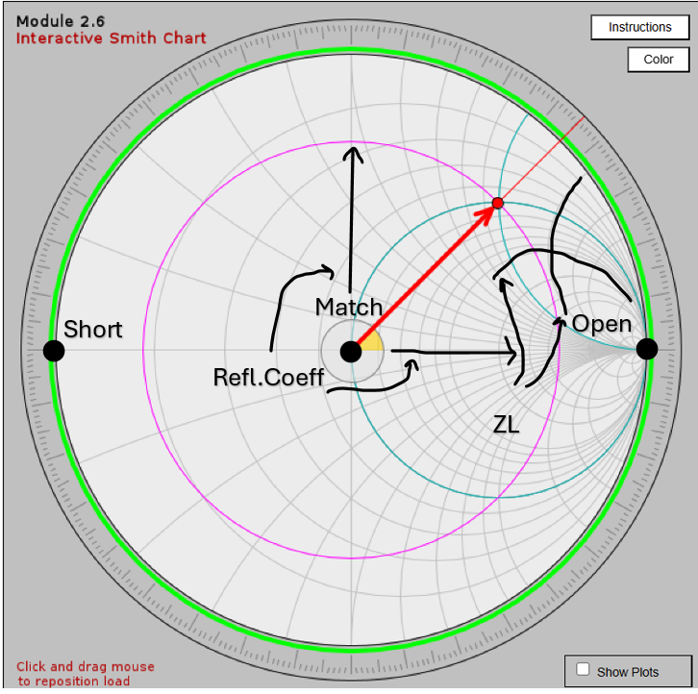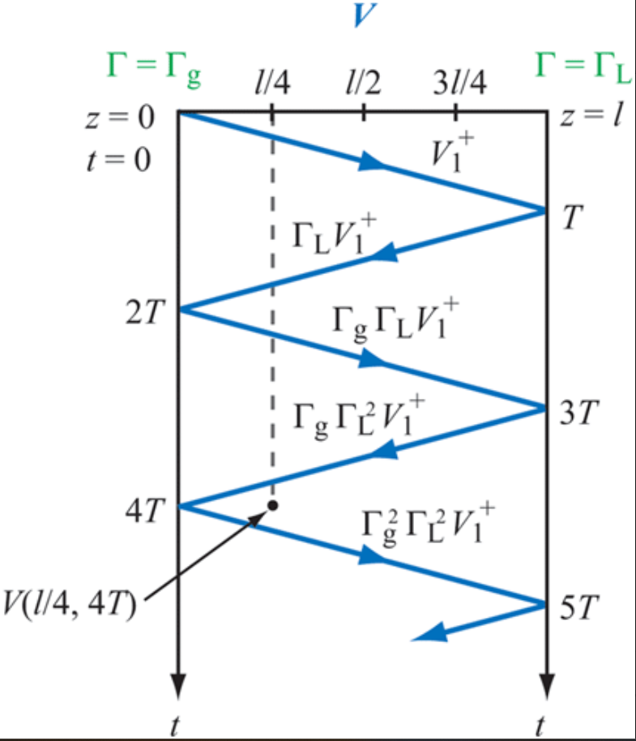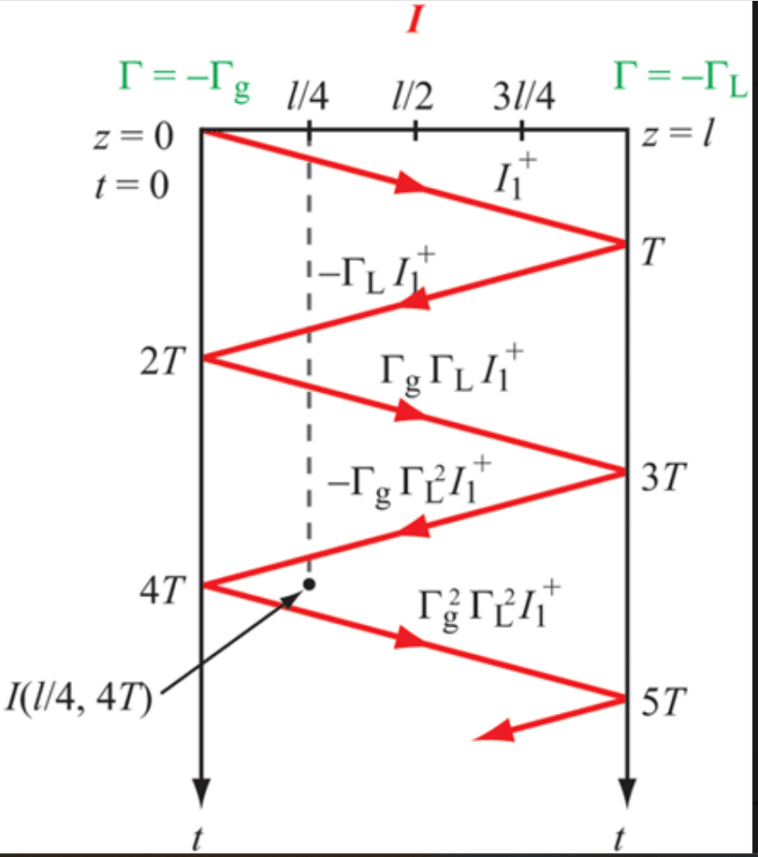

ECEN390:SLR; 1mile = 1609m; λ=c/f; c=3*10^8m/s; $Asin\left(ωt\right)→Ae^{-\frac{jπ}{2}}$; $\cos\left(θ\right)+jsin\left(θ\right)=e^{jθ}$
$Acos\left(ωt+θ_{0}\right)→Ae^{jθ_{0}}$; $Ae^{-αx}cos\left(ωt+{βx+θ}_{0}\right)→Ae^{j\left(βx+θ_{0}\right)}$; $Asin\left(ωt+θ_{0}\right)→Ae^{j(θ_{0}-\frac{π}{2})}$;
$x=|z\left|cosθ;y=|z\right|sinθ;\left|z\right|=\sqrt[+]{x^{2}+y^{2}};θ=artan(\frac{y}{x})$; $z=\left|z\right|e^{jθ}=\left|z\right|∠θ$;
$\frac{l}{λ}=electrical length;$ TlineShort: $Γ=-1, 180°phase;$ TlineOpen: $Γ=1, 0°phase;$
BounceDia: Add up segments up to that point. ; $y\left(x,t\right)=Acos(ωt-\frac{2π}{λ}x+θ_{0})$ $β=\frac{2π}{λ};u_{p}=fλ=\frac{ω}{β}$
$$A∙B=ABCosθ_{AB}=a_{1}b_{1}+a_{2}b_{2}+a_{3}b_{3};\left|A\right|\left|B\right|→0°;-\left|A\right|\left|B\right|→180°$$
$AxB=\hat{n}ABsinθ_{AB}=\hat{x}\left(A_{y}B_{z}-A_{z}B_{y}\right)+\hat{y}\left(A_{z}B_{x}-A_{x}B_{z}\right)+\hat{z}\left(A_{x}B_{y}-A_{y}B_{x}\right);$mag=areain//ogram
Cylind.:$r=rad distance,ϕ=°from Xaxis, z=Vertplane;r=\sqrt[+]{x^{2}+y^{2}};ϕ=\arctan\left(\frac{y}{x}\right);z=z$
$$dS_{r}=\hat{r}rdϕdz;dS_{ϕ}=\hat{ϕ}rdrdz;dS_{z}=\hat{z}rdrdϕ;$$
Spher.:R=originToPoint; $θ=from pos Zaxis;ϕ=see cylind;R=\sqrt[+]{x^{2}+y^{2}+z^{2};}θ=\frac{\sqrt[+]{x^{2}+y^{2}}}{z};ϕ=cylind$
$$dS_{R}=\hat{R}R^{2}sinθdθdϕ;dS_{θ}=\hat{θ}Rsinθdθdϕ;dS_{R}=\hat{ϕ}RdRdθ;$$
$$\text{∇∙}\text{A}\text{(}\text{cart)=}\frac{∂A_{x}}{∂x}+\frac{∂A_{y}}{∂y}+\frac{∂A_{z}}{∂z}; \text{∇}\text{x}\text{A}\text{(cart)}\text{=}\hat{x}\left(\frac{∂A_{z}}{∂y}-\frac{∂A_{y}}{∂z}\right)+\hat{y}\left(\frac{∂A_{x}}{∂z}-\frac{∂A_{z}}{∂x}\right)+\hat{z}\left(\frac{∂A_{y}}{∂x}-\frac{∂A_{x}}{∂y}\right)$$
$$∇\left(cart\right)=\hat{x}\frac{∂}{∂x}+\hat{y}\frac{∂}{∂y}+\hat{z}\frac{∂}{∂z};∇\left(cyl\right)=\hat{r}\frac{∂}{∂r}+\hat{ϕ}\frac{1}{r}\frac{∂}{∂ϕ}+\hat{z}\frac{∂}{∂z};∇\left(sphr\right)=\hat{R}\frac{∂}{∂R}+\hat{θ}\frac{1}{R}\frac{∂}{∂θ}+\hat{ϕ}\frac{1}{RSinθ}\frac{∂}{∂ϕ};$$
$\text{∇∙}\text{A}\text{(}\text{sphr}\text{)}=\frac{1}{R^{2}}\frac{∂}{∂R}\left(R^{2}A_{R}\right)+\frac{1}{Rsinθ}\frac{∂}{∂θ}\left(A_{θ}sinθ\right)+\frac{1}{Rsinθ}\frac{∂A_{ϕ}}{∂ϕ};\text{∇∙}\text{A}\text{(}\text{cyl}\text{)= }\frac{1}{r}\frac{∂}{∂r}\left(rA_{r}\right)$ +$\frac{1}{r}\frac{∂A_{ϕ}}{∂ϕ}+\frac{∂A_{z}}{∂z}$
$$\text{∇}\text{x}\text{A}\text{(}\text{sphr}\text{)}=\hat{R}\frac{1}{RSinθ}\left[\frac{∂}{∂θ}\left(A_{ϕ}sinθ-\frac{∂A_{θ}}{∂ϕ}\right)\right]+\hat{θ}\frac{1}{R}\left[\frac{1}{Sinθ}\frac{∂A_{R}}{∂ϕ}-\frac{∂}{∂R}RA_{ϕ}\right]+\hat{ϕ}\frac{1}{R}\left[\frac{∂}{∂R}(RA_{θ})-\frac{∂A_{R}}{∂θ}\right]$$
$$\text{∇}\text{x}\text{A}\text{(}\text{cyl}\text{)}=\hat{r}\left(\frac{1}{r}\frac{∂A_{z}}{∂ϕ}-\frac{∂A_{ϕ}}{∂z}\right)+\hat{ϕ}\left(\frac{∂A_{r}}{∂z}-\frac{∂A_{Z}}{∂r}\right)+\hat{z(}\frac{1}{r}[\frac{∂}{∂r}\left(rA_{ϕ}\right)-\frac{∂A_{r}}{∂ϕ}])$$

